Nathan Ketterlinus

ENGL317

Professor Charney

9/22/23

Journal #6

* Comparison of your stock with the competitors' stock over the lifetime of your company's history. This should also include a comparison with the S&P 500, which I would consider a baseline measurement.

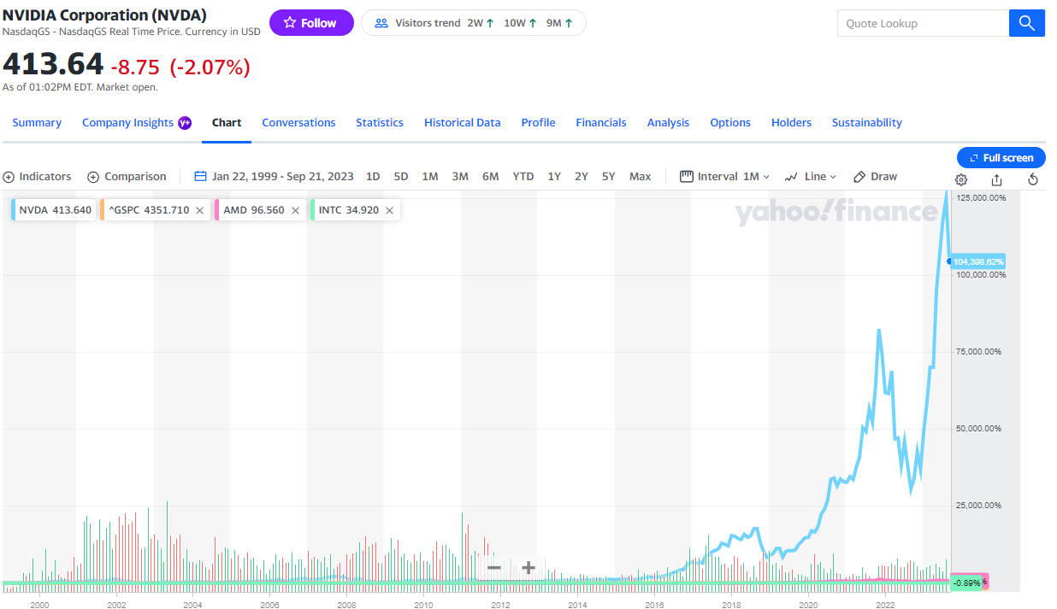

Image 1: comparison between Nvidia Corporation (NVDA, light blue), Advanced Micro Devices, Inc. (AMD, Pink), Intel Corporation (INTC, green), and S&P 500 (GSPC, orange), since 1/22/99, scaled by percentage (Yahoo, 2023a).

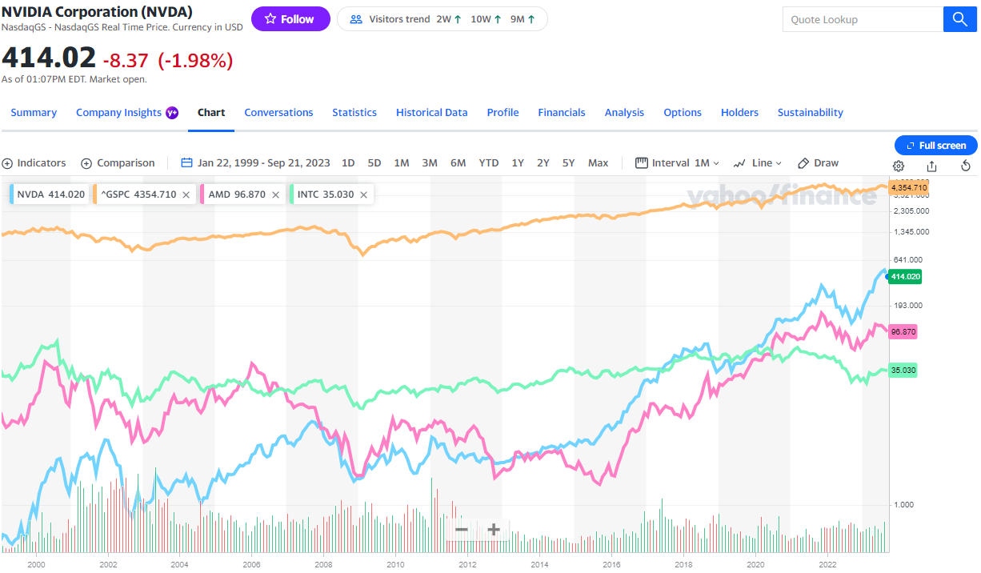

Image 2: comparison between Nvidia Corporation (NVDA, light blue), Advanced Micro Devices, Inc. (AMD, Pink), Intel Corporation (INTC, green), and S&P 500 (GSPC, orange), since 1/22/99, scaled logarithmically (Yahoo, 2023b).

* Comparison of the stock's recent performance so we can see where it stands in at least the last year. Include the S&P performance in this graphic as well.

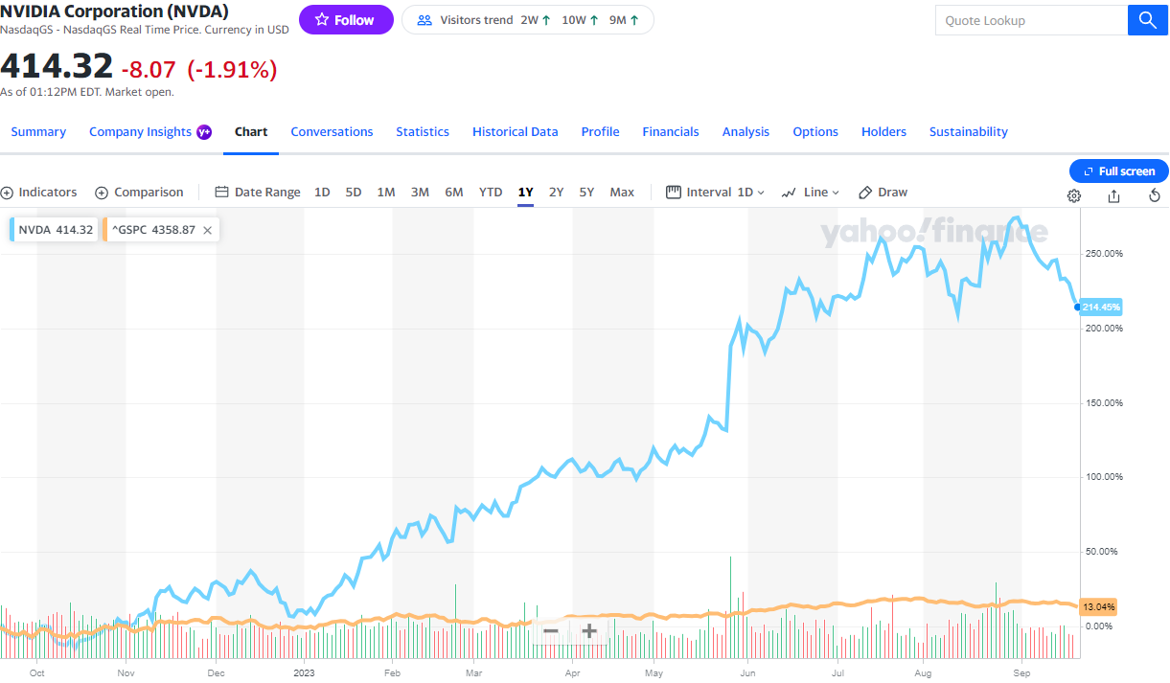

Image 3: comparison between Nvidia Corporation (NVDA, light blue) and S&P 500 (GSPC, orange), from 9/21/22 to 9/21/23, scaled by percentage (Yahoo, 2023c).

Apologies for the references, there are three of them, but the URLs are incredibly long. I believe that Yahoo Finance includes every single possible argument that the graph can use in the URL, contributing to its length. On the positive side, I believe that this means that by opening the links, you see them exactly as I saw them when making this journal, although I am not one hundred percent sure.

References

Yahoo! (2023a, September 21). *Nvidia Corporation (NVDA) Interactive Stock Chart*. Yahoo! Finance. https://finance.yahoo.com/quote/NVDA/chart?p=NVDA# --

Yahoo! (2023b, September 21). *Nvidia Corporation (NVDA) Interactive Stock Chart*. Yahoo! Finance. https://finance.yahoo.com/quote/NVDA/chart?p=NVDA#

Yahoo! (2023c, September 21). *Nvidia Corporation (NVDA) Interactive Stock Chart*. Yahoo! Finance. https://finance.yahoo.com/quote/NVDA/chart?p=NVDA#-